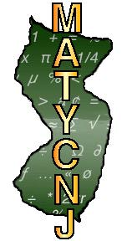

Executive Committee of MATYCNJ
President - Gabriela Sprague  Brookdale Community College  gsprague@brookdalecc.edu | Treasurer - Lenore Lerer  Bergen Community College  llerer@bergen.edu
President-Elect - Sally Mulvey  Brookdale Community College  smulvey@brookdalecc.edu | Recording Secretary – Karina Aliaga  Brookdale Community College  kaliaga@brookdalecc.edu
Past- President – Meimee Persau  County College of Morris  mpersau@ccm.edu | Newsletter Editor/Historian  Daniel Lopez  Brookdale Community College  dlopez@brookdalecc.edu
Vice President North  Palma Benko  Passaic County Community College  pbenko@pccc.edu | Vice President South  Ashley Tasy  Brookdale Community College  atasy@brookdalecc.edu

