IT Project Request Form FAQs

Submit this form for anything that requires scheduling of IT resources.
Urgent, Operational or Compliance-related requests should be submitted to helpdesk@brookdalecc.edu. Call 732-224-2829 for emergencies.

Who is the Requester / Point Person?
Requester Information
Name: | Click or tap here to enter text.
Email: | Click or tap here to enter text.
Phone: | Click or tap here to enter text.
Institute: | Click or tap here to enter text.
Department: | Click or tap here to enter text.

Have you received supervisor approval to pursue this request?
☐Yes ☐No ☐ Other. Please explain: Click or tap here to enter text.
Supervisor email:Click or tap here to enter text.

Project Title: Click or tap here to enter text.

What is the Request?
Click or tap here to enter text.

What are the Project Goals and Objectives? Describe how they align with Institutional Strategic Initiatives (e.g., Academic Master Plan)
Click or tap here to enter text.

Who will be Impacted by this request and how?
Click or tap here to enter text.

Anticipated or preferred implementation timeline:
Start Date or MM/YYYY: | Click or tap to enter a date. | Completion Date or MM/YYYY: | Click or tap to enter a date.

What is the estimated cost of project if known?
Cost for 1st Year: | Click or tap here to enter text. | Cost after 1st Year: | Click or tap here to enter text.

Read the brief descriptions of each committee and select the most appropriate committee to review your request.

Committee Choose an item.:

Frequently Asked Questions / Steps for Submitting IT Project Requests
Q. Is there a deadline for submitting IT Project Requests?
A. IT project requests can be submitted throughout the year, but must be received by October 1st for full consideration in the next fiscal year budget. To be considered for inclusion in the FY20 budget (i.e., the budget year that begins 7/1/19), a project must be submitted by October 1, 2018.
Q. What kinds of projects should the form be used for? Do I need to fill out this form for routine services like software updates?
A. Complete the form if you require IT resources for a non-routine request. Routine requests, compliance issues, and regulatory demands should be submitted to helpdesk@brookdalecc.edu. For emergencies, call 732-224-2829.
Q. How do I know what a routine request is compared to an IT Project Request?
A. Use the rubric below to determine if your request is considered routine service vs a project. Information Technology staff can assist you in this determination. After reviewing the project rubric, if you are still uncertain, submit an email to OIT at helpdesk@brookdalecc.edu describing your technology request with as much detail as possible.

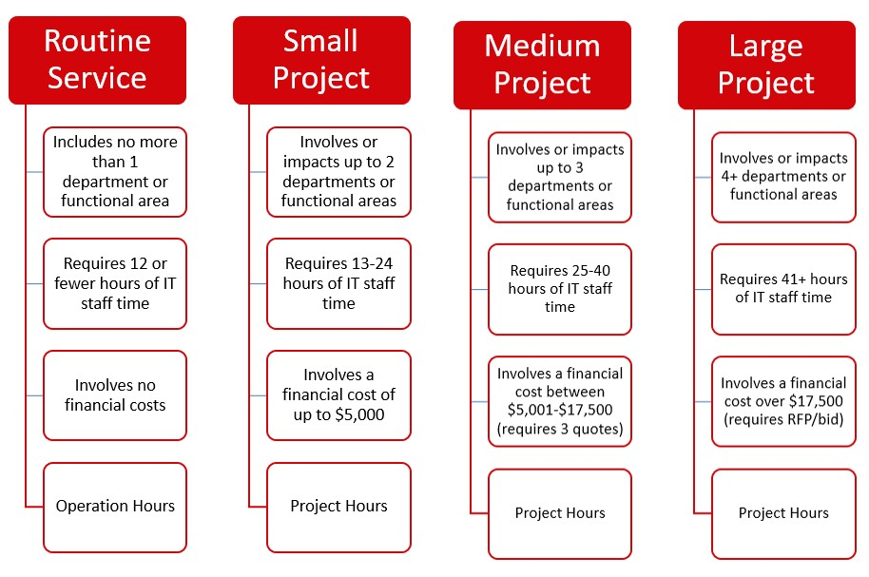

Q. Who can submit a project request?
A. Requests can be submitted by an individual or a department.
Q. Does my supervisor need to approve this request before I submit the form?
Supervisors will receive an email regarding submission of your request. Supervisors will indicate their approval by returning an email confirmation. In the event that a supervisor confirmation email is not returned, the appropriate IT Standing Committee will follow up with the requestor.
Q. What are the stages of an IT Project Request?
A.

Three Phases of Information ^{1. Project} 2. Project 3. Project
Request by Evaluation by Prioritization
Technology Project Requests: Individual / IT Standing by IT Steering
Department Committee Committee

Q. Who will review the projects? How do I know which IT Standing Committee to select to review my IT Project Request Form?
A. When an IT Project Request Form is submitted, the requestor indicates which one of the four IT Standing Committees should review the request. Click here to review the scope of authority of each IT Standing Committee.
Q. What is the process for reviewing IT project proposals?

The identified IT Standing Committee reviews the request to confirm that it falls under the committee’s scope of authority. If the IT Standing Committee determines that the request is more appropriate for review by a different IT Standing Committee, the request will be forwarded to that committee.

The project is reviewed in terms of alignment with Institutional Strategic Initiatives (e.g., Academic Master Plan) and departments or functional areas impacted. Office of Information Technology (OIT) staff will be consulted to provide estimates of anticipated hours of OIT staff time, financial cost, total project hours, etc. The IT Standing Committee evaluates each project in relation to other project requests it receives. The IT Standing Committee also considers the implications of not moving forward with the project.

IT Standing Committees will review requests monthly as IT Project Requests are received to determine if there are questions or if clarification is needed from the requestor, and to receive initial OIT input regarding estimation of project costs and OIT hours that will be required. After this initial review process, the IT Standing Committee will review all requests received, by the October deadline, at the Committee's October meeting to determine recommended institutional priorities. All reviewed requests will be sent to the Technology Steering Committee by November 1st for final IT Steering decision by early December of each year. Exceptions to this review process will be at the discretion of the IT Steering Committee.
Q. How are the final decisions made?
A. The IT Standing Committees will forward all requests to the Technology Steering Committee with recommendations for prioritization. The Technology Steering Committee will evaluate and prioritize the requests for the fiscal year.
Q. When can I expect to hear about a decision regarding my request?
A The requestor will be informed via email at all phases of the proposal review. An immediate confirmation email will be sent upon submission of IT Project Request Form. The IT Standing Committee will provide a response to the requestor within one month of the request, stating the status of the request. Standing Committees will forward all requests to the Technology Steering Committee with recommendations for prioritization. The Technology Steering Committee will evaluate and prioritize the requests for the next fiscal year.
Q. What steps might be needed on my part after the project is approved?
A. The requestor will be expected to participate in the development of the project plan, including identification of individuals anticipated to work on the project. The requestor is typically responsible for coordination and implementation of the project with OIT technical support and direction.

