There are multiple pathways to your State of New Jersey
State-Issued High School Diploma
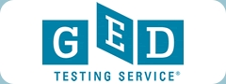
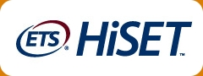
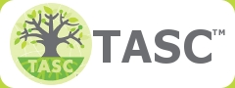
Test Assessing Secondary Completion Computer or Paper Subject Areas
Language Arts
- Reading & Writing
Science, Social Studies,
Mathematics
$92 non-refundable
$10 administration per subsection paid to test center After 2nd retest $20.40 for each retest.
High School Equivalency Test
Computer or Paper
Subject Areas
Language Arts
- Reading & Writing
Science, Social Studies,
Mathematics
$90 non-refundable
$10 administration per subsection paid to test center. After 2nd retest, $25 for each retest.

General Education Development
Computer-based
Subject Areas
Language Arts
- Reading & Writing
Science, Social Studies,
Mathematics
$120 non-refundable
Up to 2 free retakes
The State of New Jersey
Board of Education
John q. Public
High School Diploma

Commissioner of Education
Testing Centers
For a listing of High School Equivalency testing centers in your area, see:
nvedu.org/testcenters
Not all options are available at all test centers. Some restrictions apply. Examinees must meet certain eligibility requirements. Additional services not included in price. Inquire at local testing center for complete details.

