Department | School | Dean Approval:

Context
This 2026-2027 department plan template has been developed to prioritize assessment, career communities, and poverty-informed educational practices in the service of our North Star Goal:

- Double our credential completion rate by 2030

For our academic departments, this means a focus on improving our student success rate and our retention rate, as well as helping students understand the importance of earning an Associate degree to facilitate seamless transfer of their General Education courses.

Instructions
Step I: Complete Column A in Part 1
Step II: Complete Columns A & B in Part 2
Step III: Complete Columns A & B in Part 3.
Step IV: Submit the document by September 30, 2026.
Step V: Complete the Curriculum Map (Part 4) by June 30, 2027.
- If your department oversees more than one program, please duplicate the Curriculum Map template and complete one map per program.
Step VI: Complete all charts and the curriculum map(s) and submit the updated document by June 30, 2027.

Note: If your department contains multiple disciplines, you may choose to separate out goals by discipline. For example, in the Department of Anthropology, Philosophy, and Sociology, some goals may be relevant to all three disciplines while others may be relevant only to one.

Part 1: Program Review Recommendations
Please include all recommendations from your last program review, even those you have already completed.
Column A  Approved recommendations from last Academic Program Review | Column B  Progress Made and Current Status

Part 2: Course, Gen Ed, and Program Learning Outcome Assessment Results
Please complete the table below.
Column A  Course or Program Learning Outcome Assessment Description  (Course number, Title, CLO, PLO, ILO, Year) | Column B  Course, Gen Ed, or Program Learning Outcome Assessment Result | Column C  Department Response  (including when intervention will be implemented)
Example: ENGL 121, CLO #1, assessed Fall 2026

Part 3: Department Initiatives
- Identify 3 – 5 goals for your department in the table below.
- These goals must map to at least two of the following priorities (A, B, and C), which are in turn connected to the college’s Strategic Plan 2030:
  - Learning outcomes assessment - CLO, PLO, ILO (SP30 Priority 1, Strategy 4)
  - Poverty-informed practice (SP30 Priority 1, Strategy 1)
  - Career Communities (SP30 Priority 1, Strategy 2)

Column A  Department Goal | Column B  Priority (A, B, or C) | Column C  End-of-Year Updates (Bullet Points)

For reference, a guide to setting poverty-informed goals may be found on page 4. The three pillars of career communities are:
- Foster strong community building among students.
- Provide coordinated and intentional student support inside and outside the classroom.
- Strengthen the link between academic learning and extracurricular experiences.

Part 4: Curriculum Map: PLOs to ILOs
Please complete the table below for the career courses in each program housed in your department. Insert your program’s PLOs in the top row. Then, use an “X” or check mark to indicate which PLO corresponds to the ILOs in the left colum. You will not need to complete a Curriculum Map every year, but we do need new or updated PLO to ILO maps for 2026-2027.

Program Name:
ILOs | PLO 1: [Insert here] | PLO 2: [Insert here] | PLO 3: [Insert here] | PLO 4: [Insert here] | PLO 5: [Insert here]
Written and Oral Communication
Quantitative Knowledge and Skills
Scientific Knowledge and Reasoning
Technological Competency
Society and Human Behavior
Humanistic Perspective
Historical Perspective
Ethical Reasoning and Action
Information Literacy

Poverty-Informed Educational Practices: Sample Department Goals
(Created by the Center for Transformative Learning)
The 3 pillars of poverty-informed practice in higher education are:
Belonging, Basic Needs, and Just-In-Time-Supports (Dull). We are creating a welcoming, supportive, and resource-connected environment for all students. Everyone benefits. Access is for everyone.
Each department is invited to identify at least one goal as a poverty-informed educational practice. Below are examples you can integrate into your discipline. These may spark other ideas as well. When drafting your goal, consider how you’ll measure progress for the “End-of-Year Updates” column.

1. Addressing Basic Needs
Goal Examples:
- Ensure all course syllabi in the department include a basic needs statement and link to current campus/community resources. (Metric: % of syllabi updated)
- Coordinate a resource awareness activity (e.g., scavenger hunt, “learning lab selfie” visits) for students in at least one course per program. (Metric: # of participating students)
- Create and maintain a one-page resource guide for all department students. (Metric: Guide updated annually and distributed to all sections)
Why it matters: Connecting students to emergency aid, food, and housing resources improves academic outcomes and retention. It’s not about having resources available; it’s about building a student’s capacity to ask for, and subsequently receive, the help they need.
- Dr. Chad Dull visited Brookdale spring of 2025. Below are his ideas for the syllabus from his powerpoint presentation. Here is a CHECKLIST developed for you for ease. LINK This CHECKLIST breaks down Dull’s suggestions in digestible and actionable compounds, with examples on what these ideas look like.
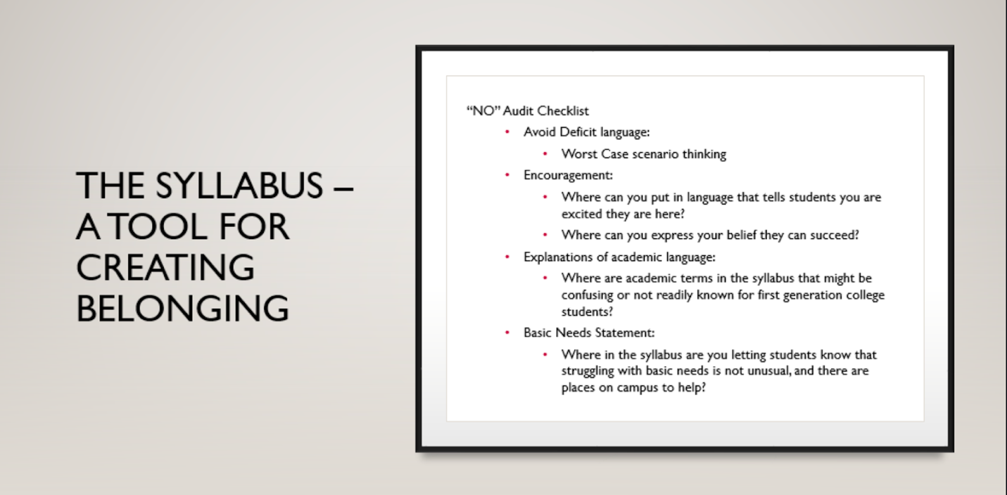

2. Flexible & Inclusive Learning Environments
Goal Examples:
- Adopt tiered/flexible deadlines for at least one major assignment in every course. (Metric: # of courses implementing flexible deadlines)
- Provide multiple assessment options across all gateway courses; to demonstrate mastery. (Metric: Types of assessments offered in each course)
- Audit all department courses for UDL principles and ensure materials are accessible in at least two formats (text, audio, video). (Metric: % of courses meeting UDL standard)
- Pre-emptively anticipate and welcome Alert Forms. Clarify what these forms are and their purpose in supporting students. Because of stigma and access to care–Some students may need support but not have a diagnosis. Encourage a visit to Accessibility Services.
Why it matters: Universal Design for Learning improves engagement and learning outcomes for diverse student populations, including low-income and first-generation students. Poverty-informed practice is a way toward a UDL campus.

3. Supportive Classroom Climate
Goal Examples:
- Implement regular check-ins (verbal, digital, or anonymous) in all 100-level courses. (Metric: # of check-ins conducted per semester)
- Create peer-support structures (learning labs, study pods, student cohorts) in at least one course per program. This helps facilitate friendships too. (Metric: Student feedback on peer-support effectiveness)
- Incorporate reflective learning activities in at least two assignments per semester. Reflective learning means giving a student an opportunity to connect the content to their lived experience. (Metric: # of reflective activities completed)
Why it matters: A culture of belonging, respect, and validation is linked to higher retention and completion rates; recognizing prior experience increases engagement and self-directed learning.

4. Proactive Support Strategies
Goal Examples:
- Use an early alert/progress report system in at least 75% of courses. (Metric: # of alerts submitted and follow-ups completed)
- Standardize student hours messaging across all courses to be welcoming and clear. Change “Office Hours” to “Student Hours”. Explain that this is time for a student. Take a step further and require one visit. (Metric: % of syllabi and office door insignia with “student hours”.)
- Develop a plain-language guide for academic terms used in the department’s courses. (Metric: Guide created and distributed)
Why it matters: Early alerts and proactive advising help address student challenges before they become barriers to success; strengths-based feedback improves motivation and persistence. Early alerts require a collaboration with Advising.

5. Adult Learner Support
Goal Examples:
- Launch an adult learner peer network within the department. (Metric: # of participants and meetings held)
- Integrate recognition of prior learning into course activities for at least one program. (Metric: # of students receiving prior learning credit)
- Offer at least one flexible scheduling option (evening, hybrid, weekend) per semester. (Metric: # of flexible sections offered)
- Consider your “child care statement and policy” (syllabus).
Why it matters: Adult learners thrive when prior experience is valued, learning is relevant, and schedules are accessible.

