CURRENT TOPICS IN BIOLOGY SEMINAR SERIES
“Restoring New Jersey Urban Water Resources:
An Emerging Pollutant (Microplastics)”
Presenter: Beth Ravit PhD
Co-Director, Center for Urban Environmental Sustainability,
School of Environmental & Biological Sciences
Rutgers University

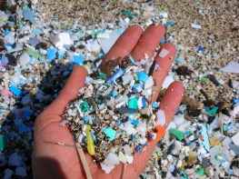

DATE: Thursday, November 15, 2018

LOCATION: MAN 105

TIME: 11:45 AM to 1:00 PM

CONTACT: Maryann Smith 732-224-1879

