**HOME HEALTH AIDE NEEDED**

**Tinton Falls – Private Residence**

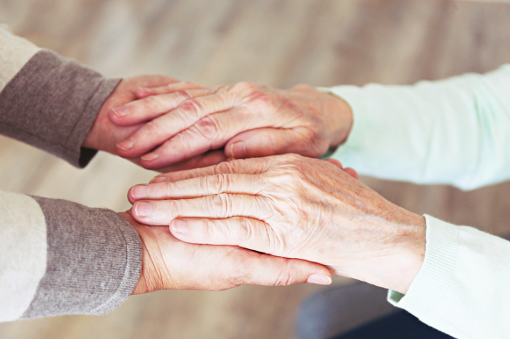

For a woman who needs light home healthcare. Would be on a flexible/occasional basis. Please use the contact info below to receive more detailed information.

George - 732-996-5036

[getbeckett@gmail.com](mailto:getbeckett@gmail.com)